New starter setup
Details needed to fill out new starter form are
- Sap position number
- Birthplace (used for Fieldglass id which is – first 2 letters of first and surname followed by day and month of birth then the first 2 characters of birthplace, e.g – AITU1806PO
- DOBx
- Full Name
- Start Date
- Title

Send off new starter form you can find this on the website under staff news then clicking on the sim card in the top left, following format so you can receive direct response from CRCUK
https://www.familyconnectgroup.co.uk/wp-content/uploads/2022/06/CRCnewstartform.xlsx Here is the link to the form.
Fieldglass ID help - 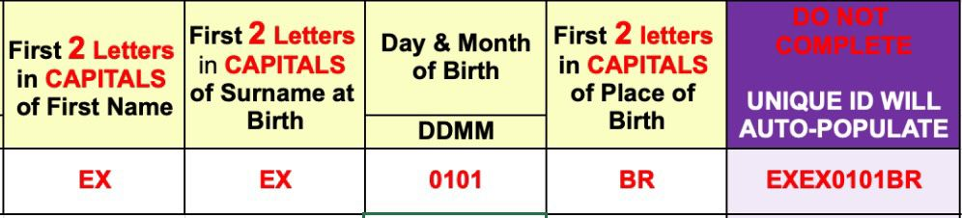
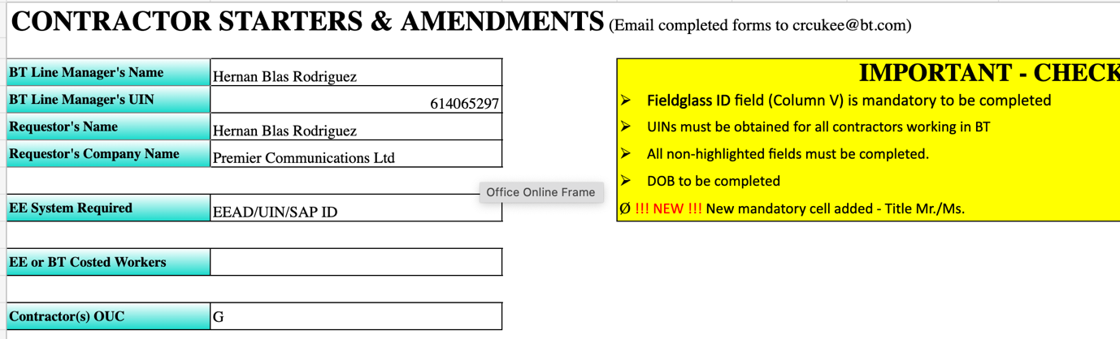
CRC normally replies to own email with new starter’s SAP ID like this, so far I have always had this done within 24 hours, like this case which was within 2 hours
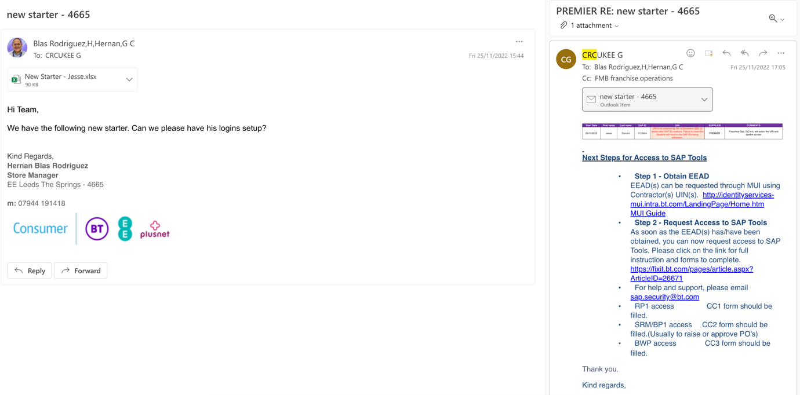

Next step is to check BT directory (found on office under quick links) to see if a BT UIN has been created, this is usually within 3 days or so.
The first Thursday after this email has been sent back, the user will have access to digital academy. The log ins are the BTUIN and the password is their Surname in lower case.

With BT UIN available. A PIN reset can be requested.
Search on toolkit “BT Password PIN Reset – for PIN resets only” – on this portal you can click Reset my password PIN. This will then send a temporary PIN to Franchise Ops and can be obtained from Aiden or David, once you have this Temp PIN, continue the reset process so a new PIN can be setup.

Now you have access to password reset portal, so can start with Digital Academy, and also reset BT UIN so access to workplace and all systems that require IUSER is available.

Next is to wait for Citrix ID (EEAD) – this will need to be sent by Aiden or David, and can take another week.

As we already have IUSER logins we can setup Workplace and Work email by following the steps on the following links
For workplace, this will link a phone number to the account for 2FA security
https://getworkplace.bt.com/

And next this link in order to open work email for the first time, this will trigger access to Office365
https://mail.bt.com/owa/
to login you would set username a “IUSER/612345678” this will setup language preferences and time zone for the user
THIS MUST BE DONE ON THE BACK OFFICE COMPUTER!
This will then allow them to use it on their phone.

After this user should begin to have access to company portal and all other apps which we will use on mobile device.
Apps that should be downloaded are -
- Bright HR
- Blip by bright HR
- Outlook
- Company Portal
- Power apps
- Teams
- Shortcut to family connect portal

By this time (a week or 2) we should already have a Citrix ID (0080xyz)

Raise a QMT following these directions – Operations -Logins -I USER
Use the following template

“Hi team,

We have the following new starter who needs access to the following systems please

Excalibur Web Lite
BT Sales and Service
Global Care
Compass Plus
Retail Insights Tool
HRC/GreetMe
Advisor Hub (RETAIL)

Advisor Name
BT UIN
EEAD Citrix ID
SAP ID”

Just keep an eye out for the response, usually within a day this gets requested and the rest is up to Franchise Ops to complete setup. 3 to 5 working days later make sure all systems are tested.

If user requires Stock Control then there is a CC1 form to be filled This can be found on the website in staff news again.

Termination of employment

Submit leaver’s request form immediately, can be done a week in advance, just make sure is not too far in advance in case logins get blocked before staff member leaves.

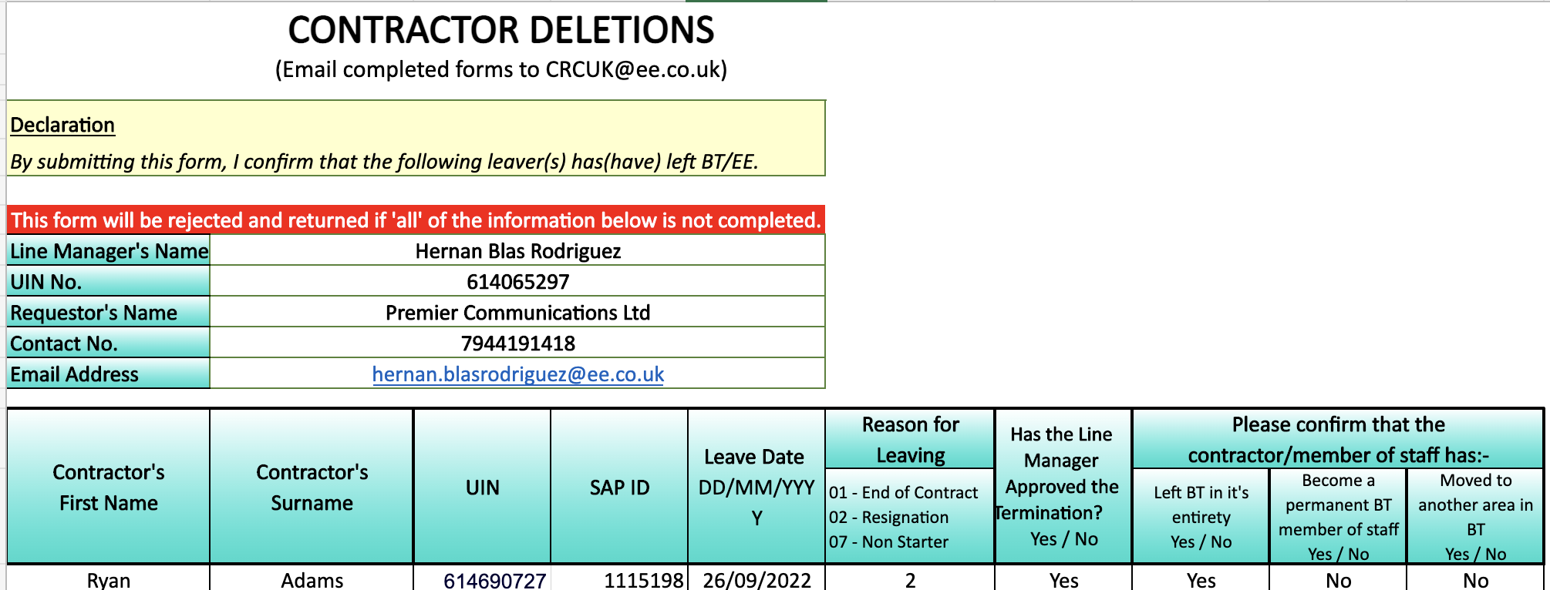

Again, if filled in this format a response will be sent to the email on the form confirming all is done, and this usually happens immediately or in this case from a Sunday to a Monday
